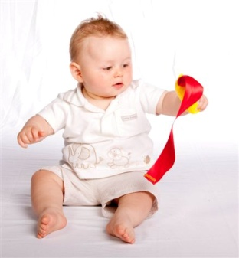
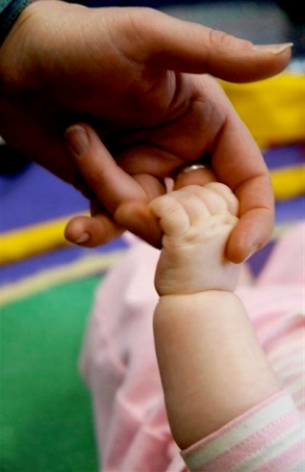
Move to Learn Course
This professional development course is fully linked to the EYFS and supports early years practitioners with the fundamental basics of why we need babies, toddlers and pre-school children to be more active. You will also receive practical ways to value, observe and support babies and children on their physical development journeys.
Practitioners will learn creative ways on how to deliver focused physical activities to individual children and groups within their day to day practice, alongside creating physical environments which will support the EYFS prime areas of learning. Integrating physical development, with social and emotional and communication.
You will also learn both the practice and theory of neuroscience and how children learn and grow. The creative practical ideas and workshop materials are easy to use and can be used over and over again giving you the confidence to use these simple, creative and exciting ways to integrate the EYFS into your daily practice.
This course is suitable for: child care practitioners in nurseries, playgroups and childcare settings, child-minders and all those interested in early childhood development.

Move to Learn: Babies and Young Toddlers
- Learn how important it is for babies and toddlers to move
- Understand the importance of Tummy Time and crawling
- Learn how increasing movement is fundamental for further learning
- Explore the links between physical development and the EYFS
- Learn ideas of how to include all children, including those with special needs or English as an additional language
- Creative practical ideas and workshop material
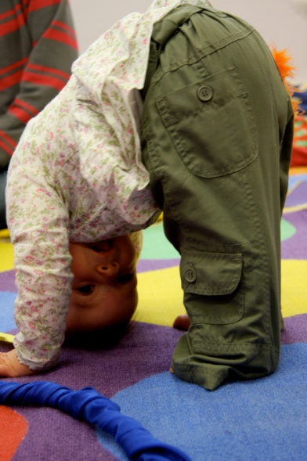
- Understand the importance of the environment to the development of babies and young children

Move to Learn: Older Toddlers Pre-school
- Learn why it is necessary for toddlers and pre-school children to move and how to encourage physical development
- Learn how to make story time more exciting and develop active story telly telling techniques
- Explore the links between physical development and the EYFS
- Explore the links between physical development and writing and literacy skills
- Understand how developing creativity is necessary for future development
- Learn ideas of how to include all children, including those with special needs or English as an additional language

The two Move to Learn courses above can be taken as one full day or two half day courses, as INSET or within a local education authority training programme.
Please contact Baby Moves head office for further details and costs of training and tool kits available.

Optional tool kits
These are available if a nursery would like to purchase a tool kit to support the training. This would help with the sustainability of the training, and ensure that it is put into practice once the trainee returns to the nursery.

Testimonials
“The training was fantastic, very useful. The ideas are transferable to the workplace. I liked the way we covered all age groups as well as disability and special needs. Tutors extremely helpful and were willing to go the extra mile. Good to see that they encourage questions and adapted to our styles rather than just sticking to own format.”
“Best hands on workshop in a long time, really enjoyed it, (and free goodies even better)”
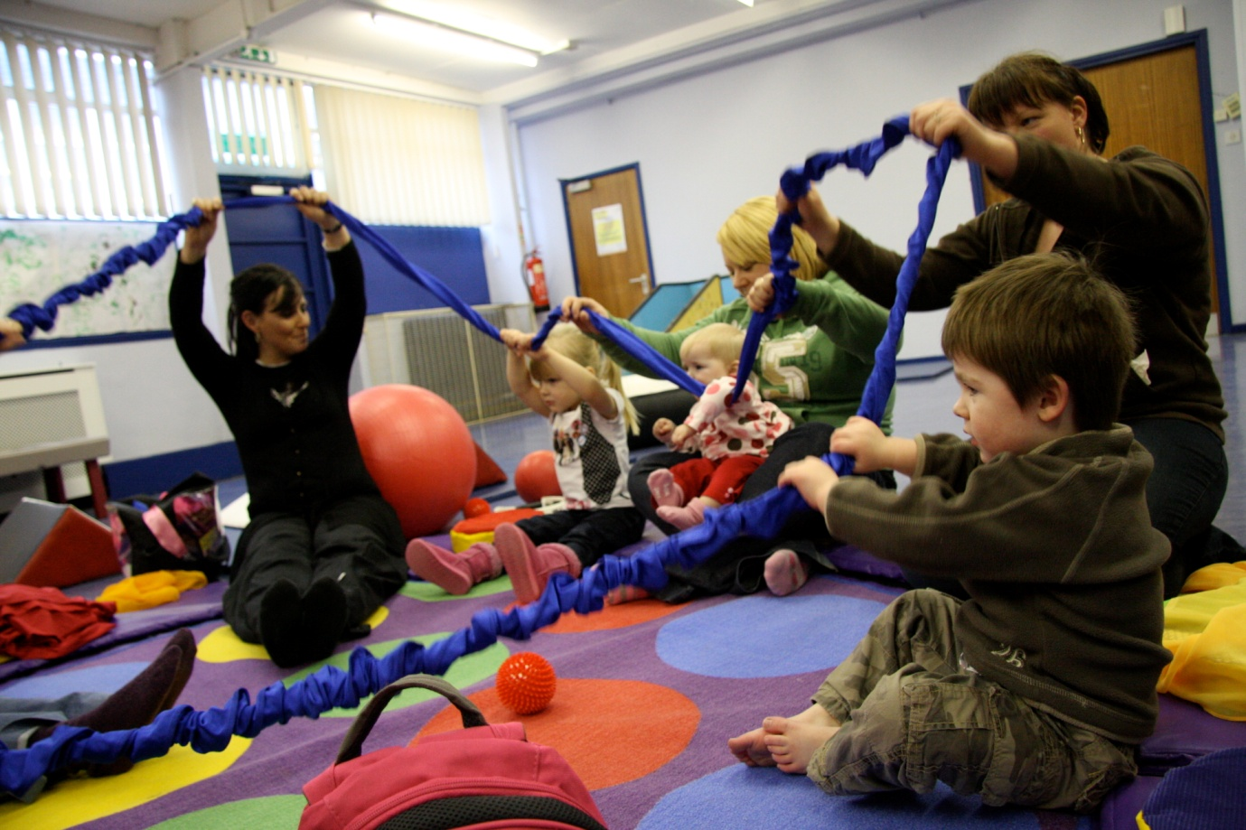
“Been a fab day! Very interesting and have learnt a lot that I can implement at work. Will pass on all the information to staff and will highly recommend this course to anyone.”

